You can refer the following resources:
- For overall glimpse of the project (including code,materials required,circuit diagram and many more) refer circuit digest
- To understand about the motor driver (which is used in this project) refer L293D Motor Driver Breakout Board

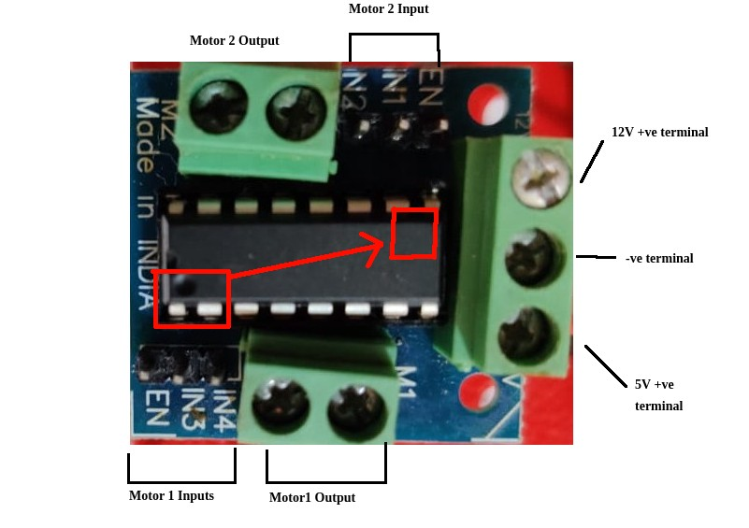
- To understand about the IR sensors (two or three) refer IR Sensor with Arduino tutorial

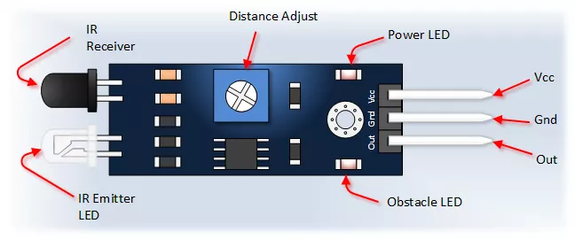

source

{
VCC is generally the positive terminal (I.e 5v in the arduino)

GND Is GND in arduino

Basically these two pins are for providing power to the sensor

OUT- is for sending data from the sensor to the arduino

}

- For the complete tutorials, refer How To Make A DIY Arduino Line Follower Car At Hom, Line Follower Robot using Arduino UNO

